22 June 2022

Dr. Jerzy Białecki
Samodzielny Publiczny Szpital Kliniczny im. Prof. Adama Grucy CMKP
Księdza Stanisława Konarskiego 13
05-400 Otwock
Poland

RE: H-34 DELTA REVISION CUP Onsite Monitoring Visit or Monitoring Follow-up Letter

Dear Dr. Białecki:

This letter is in follow-up to my monitoring visit, on behalf of LimaCorporate S.p.A. on 09 June 2022. I appreciate the opportunity to have worked with Dr. Julia Macias to discuss study progress and subject related issues. A new findings were identified during this visit. These items as well as recommendations for corrective actions are outlined below:

Findings identified during this review are noted below:

Issue Date | Finding | Action Required | Addressed to (Sponsor/Site/CRA) | Resolution date
09Jun2022 | Consent process not documented in subjects notes from patients 101-07 to 101-014 | To provide supplementary notes with the current date documenting the whole consenting process. | The site staff was instructed to provide supplementary notes. | Open

Findings identified after the visit:

Issue Date | Finding | Action Required | Addressed to (Sponsor/Site/CRA) | Resolution date
17Jun2022 | The SAE report for subject 101-014 was sent with a delay. | To retrain the site staff from safety reporting. | CRA | Open

Previous findings that remain open are noted below:

Issue Date | Finding |  | Action Required | Addressed to (Sponsor/Site/CRA) | Resolution date
18Nov2021 | Lack of copies of current GCP certificates from the site staff. | To file the current GCP certificates in ISF.  Update:  Only GCP certificate of Dr. Macias was filed in ISF. |  | Site/CRA
18Nov2021 | Subject 101/4 did not sign ICF | To check with the subject the reason why “Secondary use of data” part of the ICF was not signed. |  | Site | Partially closed on 03Feb2022
18Nov2021 | Subjects 101-2 – 101-7 did not personally date the ICF. | To collect from the subject a statement confirming that the subject agreed to participate in the study. The statement should be signed with the current date by the subject.  The missing signed statement that have not been collected so far for subjects 101-3, 101-5, and 101-6. |  | Site
03Feb2022 | Pending queries | To resolve pending queries |  | Site
03Feb2022 | eCRF was used as SD for some of the data. Including race, intensity of activity daily living, work status, smoking habits, alcohol drinking habits and radiographical description including presence of osteophytes and presence of cystis. | To provide the updated medical documentation signed with the current date to support the data completed in eCRF. |  | Site

As a reminder I would like to kindly point out that all Serious Adverse Events are required to be reported to the Sponsor within 24 hours after learning of the event. In case of explantation of the components is performed, the explanted components need to be sent to the Sponsor after decontamination.

Dr. Jerzy Białęcki, on behalf of LimaCorporate S.p.A., I would like to thank you and your staff for your cooperation in making this a successful monitoring review. If you have any questions please contact me at +48729107107 or akogut@namsa.com

Sincerely,

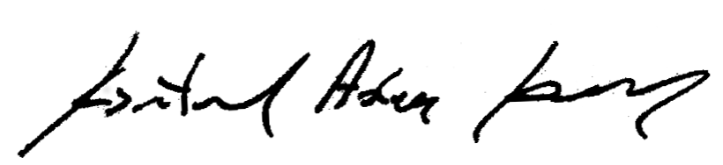

Adam Kogut
CRA

cc: Aissa Benyattou
Lisa Ciuffarin
Study File/Site File

